The Project REACH Program
Restoring Equity, Access, and Community Healing
A program designed to reduce mental health disparities, break stigma, and expand access to culturally responsive care.

Sophia Pacelli
HPRB 4400
December 2025
Table of Contents
Mission Statement: 3
Needs Assessment 5
Figure 1. Logic Model for the Community Wellness Clinic to Reduce Mental Health Barriers Among African American Men in Rural Georgia (Clay County) 10
Program Theory 11
Figure 2. The Transtheoretical Model of Change (TTM) as applied to the mental health program for Black men in rural Georgia 14
Program Description 15
Implementation Plan 17
Table 1: Proposed components of individual counseling intervention for African Americans struggling with mental health in the rural south 18
Evaluation Plan 20
Table 2: Evaluation Plan Collection Overview 25
Marketing Plan 26
Budget & Resources 29
Conclusion 37
References 38

Mission Statement:
Our mission is to significantly reduce the barriers to mental health treatment among African American men in rural Georgia by delivering culturally responsive, accessible, and stigma-free care. This initiative is made possible through a partnership with Emory Hospital to establish a community-rooted non-profit wellness clinic. Through Emory’s Collaborative Care Model, community outreach, and tailored cultural treatment approaches, this clinic will work to reduce barriers, misdiagnosis, and improve overall mental and physical health outcomes for Black men in rural marginalized communities. By eliminating barriers of cost, stigma, and distance, this clinic will strive to foster relationships with Black men to be able to create empowerment for support and trust in the care they receive.

Goal 1: Strengthen community partnership by recruiting community organizations to engage African American men in rural Georgia in mental health services.
  - Partner with at least 5-7 community-based organizations within the first six months.
  - Train at least 7-10 community members to be able to fully advocate and deliver support for individuals by the end of the first year.

Goal 2: Expand accessibility to culturally tailored, stigma-free, and most importantly, financially affordable care.
2.1- Enroll at least 100 African American men, if not more, into the wellness clinic services within the first year.
2.2- Ensure that every individual enrolled is staying consistent with their appointments to reduce missed appointment rates by at least 25% within the first 18 months of the program
2.3- Provide financial assistance to at least 60% of individuals who are uninsured or underinsured during their first year of treatment.

Goal 3: Build long-term trust and support among African American men in rural areas to help them continue to build and engage in their own mental health care.
3.1- Report at least 75% of clients showing increased trust in healthcare providers by the end of year two. This will be possible through post-care surveys.
3.2- Establish community support groups through community health centers with at least 2-3 active partnerships by the end of the first year.
3.3- Reduce self-reported stigma surrounding mental health treatment by at least 20% within the first two years.

Needs Assessment

Health Problem: Barriers to treatment for mental illness among African American men
How is it defined/measured?
African American men have continued to be disadvantaged by systemic barriers that limit accessibility to mental health care. It has been shown in multiple studies that these disparities are not a new phenomenon and have been present within this community for generations (Columbia University of Psychiatry, 2021). The 2021 National Survey on Drug Use and Health showed that only 21% of African Americans with mental health problems received help (SAMHSA, 2022). The adult Black community is 20% more likely to experience serious mental health problems, such as major depressive disorder or generalized anxiety disorder (Columbia University of Psychiatry, 2021). Mental health professionals have been concerned about the disproportionate increase in suicide among adolescent and young adult Black males (Watkins, 2017). This remains a critical public health issue because these inequities are what limit care and further health disparities. A Generalized Anxiety Disorder scale usually measures anxiety and depression, or through a patient health questionnaire. Although these tools are available, research consistently indicates a disproportionate diagnosis of mental illness. Mental illness among African American men affects them a lot more than other groups, but it is more likely to be misdiagnosed or overlooked compared to other populations (Hudson et. al, 2018). These misdiagnoses are what also play a key role in what ends up delaying treatment, irrelevant interventions, and worse overall well-being.

Who is your target population?
African American men in rural Southern regions, such as Georgia, face some of the most significant barriers to accessing mental health services, making them a central focus of this discussion. Many Georgia counties experience a shortage of mental health providers (HRSA, 2022), requiring individuals to travel long distances for care. Black men in these areas are more likely to be uninsured or underinsured—another critical barrier to treatment (Office of Minority Health, 2023). Furthermore, Georgia has the fifth-highest rate of uninsured individuals under 65 (Dixon, 2024), and this financial shortfall increases out-of-pocket costs for therapy, medication, and other treatments (cite). Cultural forces add further barriers, including stigma, fears of being judged, concerns about appearing weak or unmanly, and reputational pressure, which are all heightened in rural areas (Cofield, 2022). Historic and ongoing medical mistrust also discourages men from seeking help (Cadaret & Speight, 2018). Research shows that Black men are less likely to receive optimal treatment and more likely to be misdiagnosed, particularly for anxiety and depression (Hudson et al., 2018). Therefore, Black men in the rural South experience a unique combination of systemic, financial, and cultural barriers, reinforcing their status as one of the most underserved groups needing mental health care.

What are the costs and consequences?
Research has shown that untreated mental conditions increase the risk of chronic illnesses, such as hypertension and heart disease (Office of Minority Health, 2023). Additionally, untreated mental illness among Black men can lead to substance abuse and higher mortality rates. Cultural traditions and stigma play a major role in mental health help-seeking behavior. It was shown that Black men perceive mental health as something that conflicts with their own strengths and egos (Cadaret & Speight, 2018). The toxic masculinity norms and experiences of racialized stress end up discouraging treatment, even if the mental health concern is urgent (Cofield, 2022). Also in 2019, the economic burden of adults with mental health disorders was around $333.7 billion (Greenberg et al., 2019).

What has been done to address this health problem, and for your target population?
Efforts to address these barriers for Black men in Georgia have focused mainly on improving access and reducing stigma. Community-based programs such as Counseling Brothers of Atlanta and barbershop interventions have encouraged participation by providing welcoming spaces for Black men to express their feelings (Victor et al., 2018). Social media campaigns and increased public awareness are also fostering more culturally responsive mental health treatment (Columbia University of Psychiatry, 2021). Telehealth initiatives have brought services to rural areas, but barriers like broadband access and digital literacy limit their effectiveness (Haynes et al., 2017). While these approaches help bridge some gaps, the critical problem of cultural stigma remains the most significant barrier to mental health care for Black men.

Setting: Emory Hospital
Emory Hospital is the number one hospital in Georgia and the largest academic medical system. It has a central referral site that allows patients in rural areas or across the state to receive care. Additionally, Emory is well-equipped for these services, as it has a lot of resources and a great reputation. Emory specifically uses the Collaborative Care Model (CoCM), which allows Black men to engage with their primary care clinics instead of having to see a specialist (Emory News Center, 2023). This is significant because it allows Black men to talk about their mental health without the pressure of stigma or other barriers. The hospital also just recently received a two-million-dollar grant for a community-based program to expand on behavioral health. This is important because they have the resources to expand mental health services to underserved populations, including African American men.
By integrating behavioral health services and enhancing outreach to rural clinics, Emory Hospital seeks to address both the barriers to access, and the stigma associated with mental health care for Black men. This model allows providers to tailor treatments to cultural backgrounds and traditions. Through collaborations, such as with NeuroFlow, a behavioral health company supporting psychiatric care between appointments, Emory offers patients flexible, ongoing support (Emory New Center, 2023). These innovations help bridge service gaps, yet deeply rooted stigma in cultural norms still discourages many Black men from seeking help. Overall, Emory Hospital remains a leader in delivering and expanding mental health care for underserved Black men across the South.
Although community-based and integrated care interventions have helped these specific populations, there are still multiple barriers that continue to decrease accessibility. The common theme among the included studies is the shared sense that stigma reduction efforts need to be culturally informed and tailored to apply to African Americans (Rivera et al., 2021). Other studies have shown that the active role of collaboration between mental health providers and faith-based institutions is a key area of study with the potential for results, given the impact of medical mistrust for treatment (Rivera et al., 2021). It has also been found that men of all races who participate in online social support groups are more empathetic to problems experienced, which ends up improving their overall mental and long-term relationships (Watkins, 2017). These groups offer greater access, are more convenient, and rely heavily on written text and nonverbal responses (Watkins, 2017). It has been shown countless times that culturally responsive interventions are needed to address and promote the mental health of Black men.

Figure 1. Logic Model for the Community Wellness Clinic to Reduce Mental Health Barriers Among African American Men in Rural Georgia (Clay County)
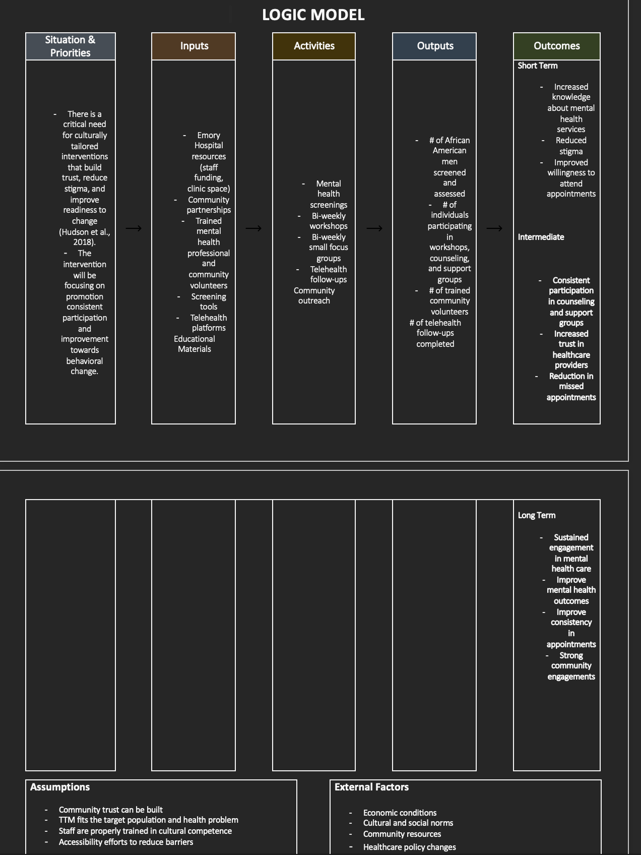

Program Theory
The Transtheoretical Model (TTM), which is also known as the Stages of Change model, provides a comprehensive framework for understanding the process of intentional behavior modification. It states that changing a behavior is not a coincidence but is a process, and different people are in different stages of change and readiness (Hashemzadeh et al., 2019). James O. Prochaska and his colleagues in the 1980s (Wilson, 2024) developed this model of behavior change. It was developed in hopes not only of guiding psychotherapists to positively change behaviors in their patients but also of explaining how individuals can change their behaviors themselves (Wilson, 2024). In this process, individuals must go through five stages: precontemplation, contemplation, preparation, action, and maintenance (Hashemzadeh et al., 2019). It is important to note that a feature of this model is that regression is as real as progression. Just because individuals move toward a positive behavioral change does not mean that they will not move back in a negative direction (Wilson, 2024). The main objective of the TTM is that the individual is heading in the right direction, not just straight into the positive end goal behavior that the individual may not be ready for. There are three factors that control the transfer between the different stages and the time necessary for change, which are: the process of change, decisional balance, and self-efficacy (Hashemzadeh et al., 2019). The process of change explains how behavioral changes occur, serving as the levers for moving from one stage to the next. Decisional balance reflects an individual’s evaluation of the pros and cons of changing a behavior. Self-efficacy refers to a person's confidence in their ability to cope without relapsing and execute the steps required for behavior change (Hashemzadeh et al., 2019).
As mentioned above, this model has six main stages that dictate how willing an individual is to accept steps towards change. The first stage is pre-contemplation. In this stage, individuals are unaware of or have limited awareness of the problem or lack insight into the consequences of their negative/addictive behavior (Raihan N., Cogburn M., 2023). Individuals also often obsess about the negative side of change rather than recognizing the benefits that they would gain. Until an individual gains insight, they remain in the pre-contemplation stage and will continue to engage in adverse behaviors (Raihan N., Cogburn M., 2023). It is necessary to note that pre-contemplators will quickly return to their old habits. This is because when individuals enter a new stage of their life, they critically evaluate their behavior and whether that behavior is actively helping them. The second stage in this model is contemplation. Awareness and acknowledgement of the problematic behavior define this stage of consideration for change (Raihan N., Cogburn M., 2023). The ambivalence and indecisiveness that occur during this stage cause individuals to remain stuck in contemplation for at least six months (Raihan N., Cogburn M., 2023). However, individuals in this stage are more open to receiving information and feedback on their behavior and finding solutions to correct it. The third stage is the preparation stage. At this stage, individuals are now easily acknowledging that their behavior is problematic, and they are starting to make a commitment to correcting it (Raihan N., Cogburn M., 2023). Individuals involved start collecting information from sources such as counseling or change-oriented programs, as this is usually their start for their plan of action. The information-gathering part of this stage is crucial in determining how individuals prepare because, without it, the impact usually isn’t as significant in their lives. Relapsing during this stage is common, but individuals make progress in terms of their thought processes. The fourth stage is the action stage, and this is usually when positive changes begin to happen. This is the stage at which individuals tend to gain confidence as they start to believe they have the willpower to continue down the continuum of change. People at this stage are willing to receive assistance and support (Raihan N., Cogburn M., 2023). The most overt behavioral changes are acknowledged by individuals and by others (Raihan N., Cogburn M., 2023). The fourth stage of this model is the maintenance stage. This is the stage where individuals have maintained total abstinence from adverse behaviors for more than six months. As individuals progress through this stage, they become more confident in their ability to sustain positive lifestyle changes, and the less tempted they feel to relapse (Raihan N., Cogburn M., 2023). They also need additional support, as this is when there is a re-evaluation of the reasons for change. The sixth and final stage of this model is termination. This stage is often not included in the full model because of how difficult it is to achieve. This is when individuals reach a point where there is zero temptation for relapse and the achievement of 100% self-efficacy (Raihan N., Cogburn M., 2023). Ultimately, the main goal of the Transtheoretical Model is to create an action plan that will assist in changing a certain behavior and maintaining that change.
The Transtheoretical Model is a very useful framework when designing a community wellness clinic that reduces barriers to mental health care for African American men in rural areas in Georgia, specifically Clay County. By identifying where individuals are in their readiness to seek treatment, the clinic can deliver culturally tailored interventions that are at every stage of change. This program is rooted in TTM, and it can help African American men progress towards consistent engagement in treatment. The clinic itself consists of multiple integrated components, such as community outreach, mental health screenings and assessments, and culturally tailored individual and group counseling. Outreach and education will stem from workshops and educational sessions that will help raise awareness, reduce stigma, and normalize treatment. The clinical component comes into play with screenings, therapy, and group counseling that are tailored to fit the needs of African American men. In addition to the clinical and educational components, this program will incorporate coping strategies to help promote active learning. Individuals will be given exercises to practice the skills learned, which helps ensure consistency and reinforcement in treatment.

Figure 2. The Transtheoretical Model of Change (TTM) as applied to the mental health program for Black men in rural Georgia

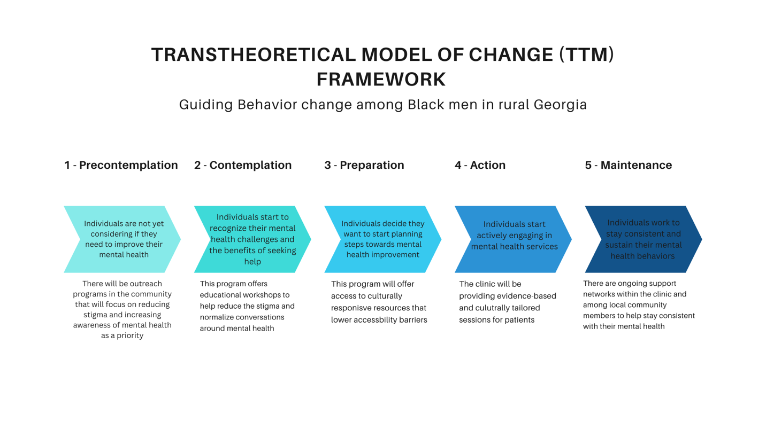

The TTM is a strong tool for changing human behavior. Research shows this model provides a framework for targeted interventions. When integrated, TTM ensures the clinic’s success and better mental health outcomes among African American men in rural Georgia. The model includes screenings, assessments, educational resources, tailored counseling, community engagement, supportive follow-ups, and telehealth after treatment. The program is based on evidence from peer-reviewed sources on mental health disparities among African American men (Hashemzadeh et al., 2019). Interventions promoting mental health and coping abilities in communities facing disparities may be the first step to improving emotional wellness among African Americans in rural areas (Haynes et al., 2017). Interventions were also adapted for systemic, financial, and cultural barriers that reduce help-seeking behaviors. Other studies further support the intervention’s effectiveness, and the behavior change theory. The design ensures it is culturally fit, accessible, and sustainable for the target population. By addressing barriers like stigma, access, cost, and transportation, and fostering trust, the program can support long-term mental health care for African American men in rural Georgia.

Program Description

This intervention is a community-based mental health program that is designed to reduce barriers to treatment among African American men in Clay County, Georgia. It combines outreach, educational resources, and culturally tailored treatment in every stage of change. Services are available weekly/biweekly through one-on-one in-person sessions at the clinic or online with the virtual telehealth option for accessibility. The team that makes this program possible is licensed counselors, program directors, data analysts, care coordinators, and health educators. As for the stages of change (TTM) regarding its integration into the program, in the precontemplation stage, men may be unaware of the benefits of mental health care and view treatment as stigmatizing. This will be addressed through outreach and education, through workshops and culturally tailored community resources to raise awareness. There will be outreach programs in the community that will focus on reducing stigma and increasing mental health as a priority. In the contemplation stage, men are aware they require mental health care but may feel ambivalent. The clinic provides information on accessible and affordable treatment options to help men consider treatment without feeling pressured by stigma. There will be educational workshops to further reduce the stigma and normalize conversations around mental health. As for the preparation stage, men start to take steps towards treatment. This means, for the clinic, pushing consistent support, culturally competent providers, reminding systems, and promoting adherence and positive outcomes. The program will offer access to culturally responsive resources that lower accessibility barriers. In the action stage, men will start to engage in mental health services actively. The program will work to provide evidence-based and culturally tailored sessions for patients. The final stage in this model is the maintenance stage, which is shown through long-term engagement. This can be achieved through follow-up surveys, community support groups, and consistent, tailored treatment. The program will have ongoing support networks within the clinic and among local community members to help stay consistent with their mental health. With the stages of change, this clinic will reinforce stability and progress at every stage, which will help create long-term and sustainable behavioral change. Overall, this intervention aims to improve mental health awareness, reduce barriers, and build trust in mental health systems among Black men in rural areas in Georgia.
Regarding the schedule of delivery, the clinic will mainly operate in person, with telehealth options to overcome transportation barriers. Services include one-on-one counseling sessions and small group support workshops. Counseling sessions will be weekly, lasting around fifty to sixty minutes, while support groups will be held bi-weekly. Program services will be delivered by a licensed counselor, a program director, and a network of trained community volunteers. The licensed counselor will provide culturally tailored therapy and conduct clinical assessments for patients, serving as the primary mental health provider. The program director will oversee clinic operations and coordinate partnerships with Emory Hospital and community organizations, ensuring the achievement of the clinic’s mission. Community volunteers will support outreach efforts, provide educational materials, and facilitate engagement between participants and clinic staff. All salaried staff and volunteers will receive training in cultural competency, intervention strategies based on TTM, and the use of the Collaborative Care Model at Emory Hospital. Materials required for smooth program operation will include culturally tailored educational resources, mental health screening tools, and telehealth platforms for online sessions.

Implementation Plan

The implementation plan will occur through preparation, program delivery, and follow-up. During the first phase, the preparation period will begin around eight weeks before the program’s launch. The program director will finalize partnerships with Emory Hospital and the local community organizations, such as churches, barbershops, and schools. All team members will be completing culturally competent training, and outside recruitment will be happening during this time. As for the recruitment of participants, this will take place by distributing flyers and hosting informational sessions that raise awareness about mental health treatment. Those who are interested in participating can complete brief intake forms and baseline screenings that can determine readiness for change. Additionally, any educational handouts and workshop materials will be finalized before launch to ensure successful implementation.
The program delivery will take place across a 24-month span and will have individual counseling sessions and group workshops. During the first year, the focus will be on the program launch, participant pool, and the consistency in service delivery. The counseling session will work to address mental health goals and stigma reduction, while the group workshops will focus on promoting a social support group and self-efficacy. As for the second year, the focus will switch to maintaining successful progress and showing consistency in engagement. The workshops and one-on-one counseling will continue with an emphasis on follow-up adherence and developing strategies to maintain mental wellness outside of the program. To support retention, the clinic will have reminder systems through text or phone calls from the care coordinator. Intervention strategies will draw on the processes of change, including reinforcement management and consciousness raising (Raihan & Cogburn, 2023).
After this program concludes, there will be a follow-up phase that will occur approximately six months later. Participants will complete surveys to assess mental health progress and treatment adherence. The clinic will continue to provide telehealth check-ins for one year after the program ends to ensure ongoing engagement and sustainable improvements in mental wellness among this population. The team will also provide summary reports on the attendance rates, participant satisfaction, evaluation results, and recommendations for additional programs that follow a similar structure.

Table 1: Proposed components of individual counseling intervention for African Americans struggling with mental health in the rural south
Sessions | Focus | Activities | Materials Needed
1-2 | - Introduction to the wellness clinic and mental health awareness  - Addressing stigma and mistrust through open dialogue about mental health in Black men | - Group discussion on personal experiences and perceptions of mental health  - Introduction to culturally relevant mental health concepts | - Handouts, informational brochures
3-4 | - Understanding mental health symptoms and stress triggers responses  - Understanding how stigma and mistrust affect care-seeking | - Group discussion on coping with stress and masculine identity  - Skill-building exercising for managing mental illnesses | - Worksheets and skill set cards
5-6 | - Challenging cultural norms that discourage open dialogue about emotional expression  - Exploring thoughts, behaviors, and beliefs tied to mental illness | - Restructuring activities that help reframe negative self-talk  - Discussion on how seeking help aligns with strength and resilience | - Videos and mini notecards for self-talk activity
7-8 | - Strengthening safety and self-efficacy  - Building confidence in healthcare engagement | - Self-esteem and self-efficacy workshops  - Peer discussion on navigating medical mistrust | - Flyers
9-10 | - Addressing practical barriers to accessing care  - Locating local mental health systems | - Group Activity: mapping out local mental health resources within local community  - Financial literacy session  - Mini workshop for assistance with appointment scheduling and telehealth setup | - Referral sheets and budgeting tools
11-12 | - Strengthening social support and long-term connection  - Building advocacy and mentorship within the local community | - Establish ongoing community-support network  - Discussion on promoting openness about mental health in rural Black communities | - Journals and discussion prompts

Evaluation Plan
African American men have continued to face significant barriers when accessing mental health care, especially in rural regions, where access to culturally tailored care is not always possible. Research has shown that systemic inequities, cultural stigma, and medical mistrust have remained strong barriers to care, which have further prevented men from seeking treatment (Cofield, 2022). Because Black men are very likely to experience inequities in mental health access, only around 21% of this population receive treatment for mental health concerns. Community-based interventions/programs must be evaluated for both effectiveness and cultural competence. This program will be assessed through formative, process, and summative measures to ensure its relevance, effectiveness, and sustainability. It is also meant to ensure that this program’s approach will reflect the lived experiences, readiness, and needs of the target population it will serve. Through the Transtheoretical Model (TTM), this evaluation plan will integrate components necessary to ensure that each objective is aligned with the participants’ readiness for behavioral change and the overall objective to help reduce mental health stigma and increase accessibility.
The first form of evaluation that will occur is the formative evaluation. This happens in the early phases of the program implementation to ensure that the community clinic is culturally tailored and relevant to the needs of African American men in those rural areas. The purpose of this evaluation is to refine the program material, recruitment methods, and interventions created before fully implementing all aspects of the program. It begins with a needs assessment that is conducted through community surveys and participant focus groups, which all help identify mental health awareness levels, barriers to treatment, and stigma found among African American men in Clay County. This data will help determine baselines for perceptions and inform culturally tailored and relevant adaptations to the intervention (Rivera et al., 2021). To be able to measure and assess participants’ attitudes towards mental health treatment, the program will use tools created for cultural relevance and alignment with the TTM. Two tools used for this will be the Mental Help Seeking Attitudes Scale (MHSAS) and some items from the Community Attitudes Toward the Mental Ill (CAMI) scale. The MHSAS is a 9-item self-report instrument designed to assess an individual’s emotional and cognitive evaluations of seeking professional mental health services (Hammer et al., 2018). This scale shows internal consistency and validity across different populations, which makes it a suitable scale for measuring readiness and attitudes. The CAMI scale measures public stigma and beliefs about people with mental illness using four key components: authoritarianism, benevolence, social restrictiveness, and community mental health ideology (Appiah-Kubi, 2019). This scale is used in different cultural contexts to measure stigma and perceptions towards mental illness, which is relevant among African American men. Furthermore, a pilot test will also be conducted to assess the durability, cultural appropriateness, and effectiveness of the Community Mental Health Clinic’s intervention before fully implementing the program. This will be measured through participants’ feedback and pre-/post-survey results, which will then be analyzed to refine the intervention and any educational/workshop materials. The purpose of this test is to see if the program’s team can correctly identify if the participants are moving through the stages of change, especially in the beginning stages. It also provides insight on whether the program’s strategies for addressing stigma, mistrust, and accessibility barriers are functioning as intended (Rivera et al, 2021). The last component of this evaluation is community engagement activities. These are activities such as meetings with local organizations, schools, churches, or barbershops that will be used to adapt materials for culturally tailored and local contexts. This process ensures that the program’s communication and focus groups align with participants lived experiences and the community norms specific to Clay County (Cofield, 2022).
The next evaluation is the process evaluation, which works on assessing how effectively the program is implemented. This stage examines and identifies strengths and barriers in delivery and ensures alignment with its guided theories (CDC, 202). It focuses on monitoring whether individual counseling sessions, educational group workshops, and telehealth components are being delivered consistently and with fidelity to the TTM framework (Hasemzadaeh et al., 2019). Continuous evaluation of participant satisfaction and program outreach ensures that interventions remain effective and responsive to the population’s lived experiences (Rivera et al., 2021). This process evaluation will assess implementation fidelity, feasibility, and logistical challenges to ensure the program maintains sustainability. Implementation fidelity is important because it ensures that each component of the program is delivered just like the original design and based on TTM. This is to be monitored through facilitator logs and team review meetings. These are important because program outcomes need to be attributed to the interventions rather than inconsistencies in delivery. Because this program is based on TTM, maintaining fidelity ensures that participants progress appropriately through the stages of change (Hashemzadeh et al., 2019). The next component is the feasibility of procedures for program delivery. This examines the practicality of implementation within available resources (CDC, 2020). This is to be assessed through post-surveys, focus groups, and one-on-one interviews with participants and counselors. It has been emphasized in previous research that culturally tailored and community-engaged mental health programs are more sustainable long-term in African American populations (Rivera et al., 2021). Ensuring that there are real-time adjustments to the program will help with feasibility and participant satisfaction, which are critical for overall development and stability of the program. The final component of this evaluation is logistical barriers to program delivery. These might be technology problems, transportation difficulties, or in-person scheduling conflicts. Based on these barriers, adjustments can be made to telehealth accessibility, mobile outreach, and more accessible session times to ensure consistency in participation. It has been shown in research that addressing logistical obstacles can significantly improve retention rates and reduce barriers in rural behavioral health care (Haynes et al., 2017).
The final evaluation in this assessment is summative. This evaluation determines the overall effectiveness of the intervention and is typically done at the end of the program. It examines the short-term changes and long-term improvements in overall health and well-being. These outcomes include changes in knowledge, attitudes, and self-efficacy to seek mental health treatment. For the impact evaluation, short-term and intermediate effects that reflect progress are measured. In terms of TTM, this means measuring participants’ progress from the precontemplation stage to the action stage. During this time, the MHSAS will be used for pre- and post-surveys to measure readiness to seek professional counseling. CAMI will also be used to assess perceived stigma towards mental health care. The scales will allow the team to be able to see any significant changes in scores before and after participation. Qualitative data will also be used from focus groups and one-on-one interviews. These combined measures will show how participants can evolve from the contemplation stage to the action stage, which stays consistent with the theory of change (Hashemzadeh et al., 2019). As for outcome evaluation, that will be assessed through changes in mental health engagements and overall well-being long term. Outcome evaluation extends beyond behavior changes to examining long-term health improvements (CDC, 2020). Some key indicators of this evaluation are consistent engagement in mental health treatment, reduced self-reported stigma, and improved mental health outcomes. Clinical outcomes will be evaluated using the Patient Health Questionnaire-9 (PHQ-9) and Generalized Anxiety Disorder-7 (GAD-7), which are important tools for measuring depression and anxiety severity (Hudson et al., 2018). These scores will be recorded at six months, one year, and two years to track improvements in engagement and symptoms. Findings have shown that consistent mental health engagement and early intervention can reduce long-term morbidity and improve overall well-being in marginalized populations (Haynes et al., 2017). Program data will serve as indicators of engagement through attendance, telehealth participation, and follow-up surveys. Because rural communities often experience low follow-up rates due to various barriers, an increase in these indicators will demonstrate success in achieving the program’s mission (HRSA, 2022). Overall, this evaluation will provide a deeper understanding of the clinic’s impact and identify areas that require improvement for sustainable progress in mental health access.
Data will be collected from surveys, scales, and one-on-one interviews and then analyzed using both quantitative and qualitative methods. The quantitative data includes PHQ-9 and GAD-7 forms, along with MHSAS and CAMI reports. These will be used with descriptive statistics and paired test to evaluate changes in attitudes and engagement (Hammer et al., 2018). Qualitative data will come from the focus groups and interviews that will help identify and assess the patterns and barriers that are related to stigma and accessibility (Rivera et al., 2021).

Table 2: Evaluation Plan Collection Overview

Indicators | Source | Collection Overview
 |  | Staff | Time Period | Methods
Formative Evaluation
Baseline mental health awareness & stigma levels | Community surveys & focus groups | Program Director & Data Analyst | First two months | Descriptive analysis
Culturally tailored program materials | Pilot test feedback forms | Program Director & Data Analyst | 3rd & 4th month | Pre and post comparisons and one-on-one interviews
Start of MHSAS and CAMI scales | Pilot test participant forms | Data Analyst & Licensed Counselor | 2nd – 4th months | Reliability testing
Process Evaluation
Intervention protocols (TTM-based counseling, focus groups) | Facilitator logs | Licensed Counselor & Program Director | 5th- 18th months | Staff monitoring
Training of staff and volunteers | Training evaluations | Program Director & Licensed Counselor | Every 2.5 months | Pre/post training assessments and surveys
Participant Attendance | Attendance Sheet | Data Analyst | Every month | Staff will have sign in sheet availble at front door and every participant will sign it
Participant satisfaction | Survey | Program Director & Data Analyst | Halfway point and at the end of program | Paper survey to fill out as well as online survey
Outcome Evaluation
Changes in depressive and anxiety symptoms | PHQ-9 and GAD-7 forms | Licensed Counselor & Data Analyst | 1st month  6th month  1 year  2 years | Descriptive analysis
Sustained engagement and reduction in stigma toward mental health care | Attendance and follow up surveys | Program Director and Data Analyst | 6th, 12th, and 1 year | Qualitative interviews
Reduction in barriers to accessing mental health treatment | Participation feedback forms, focus group data | Licensed Counselor & Data Analyst | After first year and after second year | Quantitative and qualitative analysis

Marketing Plan
Inclusion and Exclusion Criteria
This program specifically targets African American men ages 18 and older who are living in rural Georgia (Clay County and surrounding areas) and are experiencing symptoms of depression and anxiety. For the inclusion criteria, participants will be required to identify as African American, be 18 or older, and complete a short intake screening assessing their mental health needs and readiness for treatment. Additionally, forms that show participants impacted by barriers such as healthcare inaccessibility, transportation, cultural stigma, or mistrust of healthcare will be emphasized and prioritized to ensure services are culturally tailored and fit for them. As for the exclusion criteria, individuals under the age of 18 will be excluded from this program due to the requirement for adult consent. Those who are facing serious psychiatric emergencies will also be excluded since this program is meant for individuals receiving psychiatric care for depression and anxiety. Additionally, participants who end up having disorders outside of this program’s scope will be referred to a specialist.
Target Population Reach/Recruitment
Since this program is developed in a rural community, recruitment will rely solely on community promotion/engagement. This is achieved through partnerships with local churches, barbershops, community organizations, and community colleges in this area. These efforts will include distributions of flyers, brochures, hosting informational sessions, and offering free mental health screenings for participants who match the inclusion criteria. Additionally, sessions and screenings will emphasize low-to no-cost mental health treatment and community engagement. All materials needed for recruitment are accounted for in the overall program budget.
Retention of Participants
Retention of participants will happen through culturally responsive engagement and consistent communication. Outside of weekly counseling and focus groups, participants will have appointment reminders sent via SMS or email to ensure consistency in treatment. There will also be telehealth and online sessions available for those who cannot make in-person visits due to transportation or other barriers that prevent participation. As for long-term engagement, this program will have incentives such as gift cards, gift baskets, raffle giveaways, and refreshments during workshops. Additionally, providers will build trusting relationships with participants to help ease any mistrust or perceived stigmas. After this program ends, there will be telehealth options still available as well as participant check-ins six months and a year after the program ends. All participant incentives, promotional events, refreshments, and materials are allocated in the program’s budget.
Special Considerations
All participants who meet the inclusion criteria will be required to complete a detailed informed consent form that explains what participation involves, confidentiality procedures, and data collection. All providers, staff, and volunteers will follow HIPAA guidelines. Several protocols will be implemented, including procedures for emergencies that require immediate referral to emergency specialist services. Regarding stigma, mental health remains a significant barrier, especially among Black men. This program will emphasize privacy for participants to foster trust in using mental health services. It will also promote respectful community engagement to normalize participation. To help reduce stigma, informational sessions will be held at local community centers familiar to participants. Permissions and consent will be established through written agreements with Emory Hospital and any other partnering community organizations. Since this program is in a rural community, there are several barriers’ participants might face. To address this, the program will have telehealth services and online sessions at no cost for those who do not have health insurance. All telehealth services and outreach are included in the program's budget to ensure that such barriers do not prevent participation.

Budget & Resources
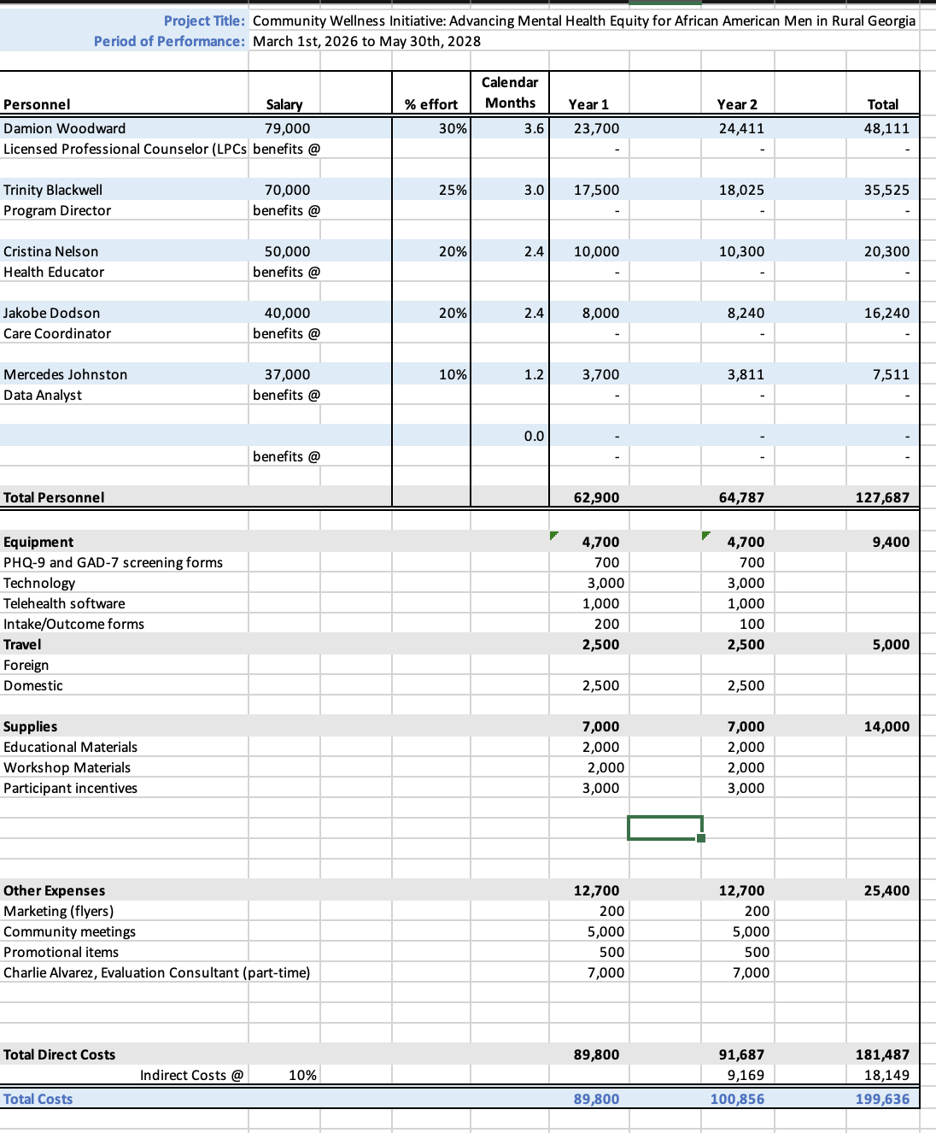

Personal

Damion Woodward, Licensed Professional Counselor- 3.6 calendar months (30% effort) in Years 1-2
Mr. Woodward is a licensed professional counselor with a master’s degree in clinical Mental Health Counseling. He has over six years of experience providing behavioral and emotional services to all individuals of age across Southeast Georgia. Mr. Woodward has also worked with other programs that have focused on improving physical and mental health outcomes among African Americans. For this program, Mr. Woodward will be responsible for overseeing all the mental health components and provide direct counseling to participants. His history of success in working within marginalized communities and his expertise in cognitive-behavioral approaches makes him qualified to lead this component.
Mr. Woodward will carry out the following duties on the proposed project:

- Year 1: Mr. Woodward will assist creating the intervention materials for the participants, train volunteers for culturally tailored practices, and provide individual and group counseling sessions. He will also be helping the community outreach events to help build trust and promote awareness of mental health services.
- Year 2: Mr. Woodward will continue to provide direct counseling and overall supervision for all participants. He will assist in evaluating intervention outcomes and make sure that participants are staying engaged as well as lessening the perceived stigma among mental health services. He will also be researching and highlighting the most effective practices that reduce barriers to mental health care among African American men.

Trinity Blackwell, Program Director- 3 calendar months (25% effort) in Years 1-2
Ms. Blackwell serves as the project’s program director. She has a Master of Public Health and over eight years of experience in directing community engagement programs throughout Georgia. Her expertise has been shown through her countless partnerships with healthcare providers, being a community leader everywhere she goes, and leading faith-based organizations to promote equitable access to care. Ms. Blackwell’s leadership skills and unique perspective will ensure that this project will be successful and sustainable.
Ms. Blackwell will carry out the following duties on the proposed project:

- Year 1: Ms. Blackwell will oversee overseeing the planning and implementation of the clinic, coordinating recruitment of staff and volunteers, and establishing community collaborations through churches and local organizations. She will also oversee developing community outreach plans to ensure all activities/programs are culturally tailored and are aligned with public health standards.
- Year 2: Ms. Blackwill will continue to manage all program activities, as well as monitoring progress towards overall reduction to mental health access barriers among African American men. She will also be leading the planning for post-grant continuation of the clinic’s services.

Cristina Nelson, Health Educator- 2.4 calendar months (20% effort) in Years 1-2
Ms. Nelson is a certified health education specialist with a Bachelor of Science in Health Promotion. She has over four years of experience in implementing community-based education programs that focus on mental health and barriers that prevent access to treatment among African Americans. She has expertise in developing culturally relevant materials and creating workshops that further the mission of bringing awareness to services and reducing perceived stigma.
Ms. Nelson will carry out the following duties on the proposed project:

- Year 1: Ms. Nelson will oversee creating and delivering the educational workshops that focus on mental health awareness, stress management, and stigma surrounding treatment. She will also be working hand and hand with the care coordinator to ensure participant recruitment/engagement as well as delivering informational materials among the local community.
- Year 2: Ms. Nelson will continue to deliver the educational workshops, refine any materials created in the last year, and support efforts in maintaining engagement among participants. She will also be assisting in evaluating participants to gauge the outcomes and how they contribute to the overall program.

Jakobe Dodson, Care Coordinator- 2.4 calendar months (20% effort) in Years 1-2
Mr. Dodson has a Bachelor of Social Work and over five years of experience in care coordination for families in low-income rural communities. His skills are connecting clients with healthcare, housing, and transportation resources, as well as, helping the barriers that prevent African American men from receiving mental health treatment.
Mr. Dodson will carry out the following duties on the proposed project:

- Year 1: Mr. Dodson will oversee managing participant intake, coordinating referrals to mental health providers, and assisting participants in any way in reducing accessibility barriers. He will also be helping families maintain ongoing communication to ensure consistent engagement.
- Year 2: Mr. Dodson will continue to provide case management services, track participant progress, and identify any new barriers to care. He will also assist the health educator with the process evaluation, by taking care notes and reporting any program improvement and outcomes.

Mercedes Johnston, Data Analyst- 1.2 calendar months (10% effort) in Years 1-2
Ms. Johnston has a Master of Science in Biostatistics and has 7 years of experience managing and analyzing data for community-based programs. Her specialty is evaluating health outcomes and disparities among minority and marginalized communities. She has worked with several public health teams to collect and analyze both qualitative and quantitative data that has supported multiple evidence-based decisions towards program developments.

- Year 1: Ms. Johnston will oversee developing the data collection for the clinic and ensuring that the clinic stays in compliance with the HIPAA standards. She will also be training any volunteers in entry-level data procedures that would assist her throughout the project.
- Year 2: Ms. Johnston will analyze outcome data to help assess changes in mental health accessibility, stigma, and overall participant engagement. She will also oversee providing summary reports for the program, as well as collaborating with the Program Director to present evidence-based findings at community events.

Travel
In-state travel (2,500 each year)
- We request $2,500 per year to be able to reimburse the project’s team for any in-state travel that is related to outreach, partnership development, and service delivery in rural communities throughout Georgia. Those who travel will be going to community centers and schools to provide workshops and host community wellness meetings. The mileage will be reimbursed at the UGA’s rate of $0.54 per mile. This would allow the team to be able to travel for an average of 90-100 miles of travel per week throughout the course of this project.

Equipment
PHQ-9 and GAD-7 Screening forms ($700 each year)
- For years 1 and 2, we request $700 each year to cover the cost of purchasing and printing screening forms for depression (PHQ-9) and anxiety (GAD-7). These screenings serve as a critical component for data collection and will guide decision making regarding referral decisions and individualized patient care plans.
Technology ($3,000 each year)
- We request $3,000 each year to be able to purchase and maintain essential technology needed to ensure successful operations of the clinic. This would include laptops, tablets, telehealth communication, and outcome tracking. These devices would also be supporting virtual counseling sessions, and overall online communications with clients.
Telehealth Software ($1,000 each year)
- For years 1 and 2, we request $1,000 yearly to purchase HIPAA-compliant telehealth platforms that allow for virtual counseling and mental health literacy sessions. Platforms will also be used for team meetings and community partnerships.
Intake/Outcome forms ($200 for year 1 and $100 for year 2)
- For this component, we request $200 for the first year and $100 for the second year. This money will be used to design and print standardized intake and outcome assessment forms. These forms will be used during initial assessments and follow-up assessments.
Supplies
Educational Materials ($2,000 per year)
- We request $2,000 per year to be able to create culturally tailored educational materials that will address mental health literacy, perceived stigma, and overall wellness. These materials include handout materials, educational books, and brochures that relate to the overall program.

Workshop Materials ($2,000 per year)
- We request $2,000 per year to be able to provide materials needed to put on interactive workshops across the local community. These materials include presentation supplies, educational toolkits, and resources needed for activities.
Participant incentives ($3,000 per year)
- We request $3,000 for both years to be able to provide incentives for participants reaching goals in their program activities. These incentives would include gift cards and wellness items that help encourage overall participant engagement.

Other Expenses
Marketing (Flyers) ($200 each year)
- We request $200 for years 1 and 2 to be able to print and distribute flyers to advertise the clinic’s services, community events, and wellness workshops. These flyers can be created on platforms such as Canva and posted at places like community centers, churches, and schools.
Community meetings ($5,000 each year)
- We request $3,000 each year to be able to host monthly community meetings. These funds would cover venues, refreshments, and educational materials needed for events.
Promotional items ($500 each year)
- We request $500 yearly to be able to purchase promotional items such as branded pens, tote bags, and water bottles that can be given away at workshops and community events.

Charlie Alvarez, Evaluation Consultant ($7,000 each year)
- We request $7,000 for both years for the services of an Evaluation Consultant that has years of experience in public health and behavioral health program evaluation. Mr. Alvarez has a Master of Public Health.
  - Year 1: Mr. Alvarez will ensure that the program’s logic model is refined as well as establish indicators for changes in mental health literacy and community stigma.
  - Year 2: Mr. Alvarez will oversee the analysis of the process and outcome data, help prepare final evaluation reports, as well as provide recommendations for the program’s sustainability.

Conclusion
Over the two years of Project REACH, the program will provide consistent, culturally responsive support to African American men in Clay County who have faced barriers to mental health care. Through individual counseling sessions, group workshops, and community-based outreach with trusted partnerships through churches, barbershops, and local organizations, the program creates a space where men can receive education, resources, and support without stigma By focusing on reducing barriers, increasing mental health literacy, and strengthening trust in health systems, Project REACH works toward closing the mental health disparities that have historically affected this population. With continued partnerships and investment, Project REACH can serve as a sustainable program for improving mental health outcomes in rural communities and ensuring that care is more equitable and accessible for all.

References
Appiah-Kubi, L. (2019). An exploratory study of the impact of stigma and acculturation on the perception of mental illness in the Black community (Publication No. 2106). Browse All Theses and Dissertations. https://corescholar.libraries.wright.edu/etd_all/2106
Cadaret, M. C., & Speight, S. L. (2018). An exploratory study of attitudes toward psychological help seeking among African American men. Journal of Black Psychology, 44(4), 347–370. https://doi.org/10.1177/0095798418774655
Centers for Disease Control and Prevention. (2020). Developing an effective evaluation plan: Setting the course for effective program evaluation. U.S. Department of Health and Human Services. https://stacks.cdc.gov/view/cdc/24531
Cofield, D. (2022). “You good, Bruh?” An exploration of the influence of race and masculinity on millennial Black men’s decisions to seek mental health treatment (Publication No. 29256850) [Doctoral dissertation, University of North Carolina at Charlotte]. ProQuest Dissertations and Theses Global.
Dixon, K., Fitzpatrick, A., & Beheraj, K. (2024). Georgia has the fifth-highest share of residents with no health insurance.Axios Atlanta. https://www.axios.com/local/atlanta/2024/08/16/georgia-uninsured-residents
Greenberg, P., Chitnis, A., Louie, D., Suthoff, E., Chen, S. Y., Maitland, J., Gagnon-Sanschagrin, P., Fournier, A. A., & Kessler, R. C. (2023). The economic burden of adults with major depressive disorder in the United States (2019). Advances in Therapy, 40(10), 4460–4479. https://doi.org/10.1007/s12325-023-02622-x
Hammer, J. H., Parent, M. C., & Spiker, D. A. (2018). Mental Help Seeking Attitudes Scale (MHSAS): Development, reliability, validity, and comparison with the ATSPPH-SF and IASMHS-PO. Journal of Counseling Psychology, 65(1), 74–85. https://doi.org/10.1037/cou0000248
Hashemzadeh, M., Rahimi, A., Zare-Farashbandi, F., Alavi-Naeini, A. M., & Daei, A. (2019). Transtheoretical model of health behavioral change: A systematic review. Iranian Journal of Nursing and Midwifery Research, 24(2), 83–90. https://doi.org/10.4103/ijnmr.IJNMR_94_17
Haynes, T. F., Cheney, A. M., Sullivan, J. G., Bryant, K., Curran, G. M., Olson, M., & Reaves, C. (2017). Addressing mental health needs: Perspectives of African Americans living in the rural South. Psychiatric Services, 68(6), 573–578. https://doi.org/10.1176/appi.ps.201600208
Health Resources and Services Administration. (2022). Designated Health Professional Shortage Areas statistics. U.S. Department of Health and Human Services. https://data.hrsa.gov
Hudson, D. L., Neighbors, H. W., Geronimus, A. T., & Jackson, J. S. (2015). Racial discrimination, John Henryism, and depression among African Americans. Journal of Black Psychology, 42(3), 221–243. https://doi.org/10.1177/0095798414567757
Office of Minority Health. (2023). Mental health and African Americans. U.S. Department of Health and Human Services. https://minorityhealth.hhs.gov
Raihan, N., & Cogburn, M. (2023). Stages of change theory. National Center for Biotechnology Information. https://pubmed.ncbi.nlm.nih.gov/32310465/
Rivera, K. J., Zhang, J. Y., Mohr, D. C., Wescott, A. B., & Pederson, A. B. (2021). A narrative review of mental illness stigma reduction interventions among African Americans in the United States. Journal of Mental Health & Clinical Psychology, 5(2), 36–45. https://www.mentalhealthjournal.org/articles/a-narrative-review-of-mental-illness-stigma-reduction-interventions-among-african-americans-in-the-united-states.html
Vance, T. (2019, February 8). Addressing mental health in the Black community. Columbia University Department of Psychiatry. https://www.columbiapsychiatry.org/news/addressing-mental-health-black-community
Victor, R. G., Lynch, K., Li, N., Blyler, C., Muhammad, E., Handler, J., Crum, R., Press, C. A., Johnson, W. D., & Wyatt, S. B. (2018). Effectiveness of barbershop-based interventions to improve hypertension control in Black men: A cluster randomized trial. New England Journal of Medicine, 378(14), 1291–1301. https://doi.org/10.1056/NEJMoa1717250
Watkins, D. (2017). Strengths and weaknesses of the young Black men, masculinities, and mental health (YBMEN) Facebook project. University of Michigan. https://deepblue.lib.umich.edu/handle/2027.42/164712
Wilson, B. (2024). Transtheoretical model of behavior change: Research starters. EBSCO Research. https://www.ebsco.com/research-starters/health-and-medicine/transtheoretical-model-behavior-change

